KARNATAK LAW SOCIETY’S

GOGTE INSTITUTE OF TECHNOLOGY

UDYAMBAG, BELAGAVI-590008

(An Autonomous Institution under Visvesvaraya Technological University, Belagavi)

**(APPROVED BY AICTE, NEW DELHI)**

Department of Electronics AND Communication



*An Internship Report on*

**FORECASTING WIND POWER USING MACHINE LEARNING**

*Submitted in the partial fulfillment for the award of the degree of*

**Bachelor of Engineering**

**In**

***Electronics and Communication Engineering***

*Submitted by*

**NAME OF THE CANDIDATE**

**NAGAMMA AJJAPPANAVAR**

**USN**

**2GI16EC083**

Internship Carried Out

at

**VENA ENERGY INFRASTRUCTURE SERVICES PRIVATE LIMITED, BENGALURU**

**Internal Guide** **External Guide**

**2019 – 2020**

Department of Electronics and Communication

KARNATAK LAW SOCIETY’S

GOGTE INSTITUTE OF TECHNOLOGY

UDYAMBAG, BELAGAVI-590008

(An Autonomous Institution under Visvesvaraya Technological University, Belagavi)

**(APPROVED BY AICTE, NEW DELHI**

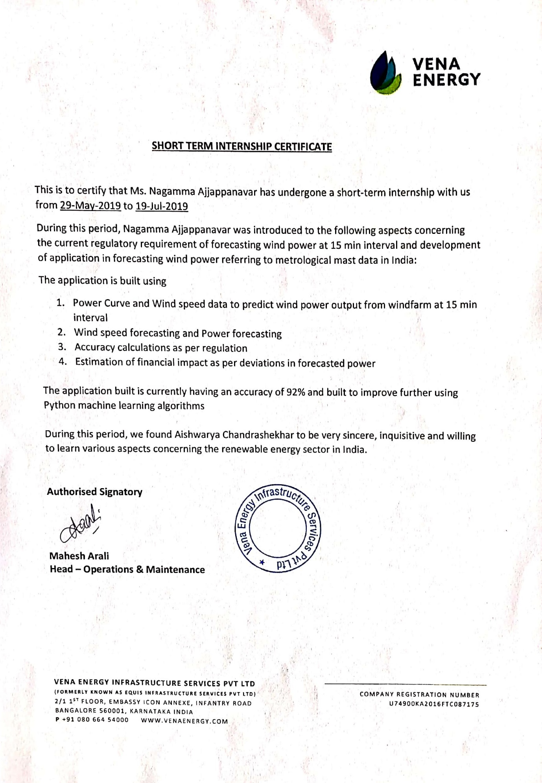

 

**CERTIFICATE**

Certified that the internship entitled Forecasting wind power using machine learning done at Vena energy infrastructure services private limited, Bengaluru Pvt Ltd. is a bonafide work carried out by Ms. Aishwarya Chandrashekar USN :2GI16EC009 in partial fulfillment for the award of **Bachelor of Engineering** in Electronics and Communication of the Visvesvaraya Technological University, Belagavi during the year 2019- 2020.

It is certified that all corrections/suggestions indicated have been incorporated in the report. The internship report has been approved as it satisfies the academic requirements in respect of Internship prescribed for the said Degree.

Signature of the Guide        Signature of the HOD        Signature of the Principal

**External Viva-Voce**

|  |  |  |  |
| --- | --- | --- | --- |
|  | **Name of the examiners** | **Date of Viva -voce** | **Signature** |
| **1.** |  |  |  |
| **2.** |  |  |  |

**DECLARATION BY THE STUDENT**

I, Aishwarya Chandrashekar hereby declare that the internship report entitled forecasting wind power using machine learning submitted by me to KLS Gogte Institute of Technology, Belagavi, in partial fulfillment of the Degree of Bachelor of Engineering in Electronics and Communication is a record of the internship carried out at VENA ENERGY INFRASTRUCTURE SERVICES PRIVATE LIMITED, PVT LTD. This report is for the academic purpose.

I further declare that the report has not been submitted and will not be submitted, either in part or full, to any other institution and University for the award of any diploma or degree.

Place: Belgaum Name of the student: Nagamma Ajjappanavar

Date: 08/08/2019 USN: 2GI16EC083

Signature of the student

Acknowledgement

This internship work consumed huge amount of work, research and dedication. The internship would not have been possible if I did not have received support of many individuals and organizations for their incredible knowledge. Therefore, I would like to extend my sincere gratitude to all of them. In particular, I would like to take this opportunity to express my honor, respect, deep gratitude & genuine regards to the staff of **Department of Electronics and Communication Engineering** of **KLS’s Gogte Institute of Technology, Belagavi** for providing me all the guidance required for the completion of the internship.

I sincerely would like to thank my guide **Prof. Ramesh Koti** for guiding me throughout this internship and also would like to thank my **Electronics and** **Communication Dr. S. S. Saraf** for giving an opportunity for the completion of internship work and giving me a platform to showcase it.

I sincerely would also like to express my deep gratitude and thankfulness to **external guide** for providing me an excellent opportunity of internship at **“VENA ENERGY INFRASTRUCTURE SERVICES PRIVATE LIMITED”** without which my work would not have been completed.

My Sincere thanks to **Dr. A.S Deshpande**, Principal, KLS’s GIT, and Belagavi who have given me opportunity of the completion of this internship.

Last but not the least I would like to thank all the people who have helped me directly and indirectly for making my internship work successful.

**(Name of the Candidate)**

**Nagamma Ajjappanavr**

The Nuclear Power Corporation of India Limited (NPCIL) is a government-owned corporation of India based in Mumbai in the state of Maharashtra. It is wholly owned by the Central Government and is responsible for the generation of nuclear power for electricity. NPCIL is administered by the Department of Atomic Energy, Govt. of India (DAE).

NPCIL was created in September 1987 under the Companies Act 1956, "with the objective of undertaking the design, construction, operation and maintenance of the atomic power stations for generation of electricity in pursuance of the schemes and programs of the Government of India under the provision of the Atomic Energy Act 1962." All nuclear power plants operated by the company are certified for ISO-14001 (Environment Management System).

NPCIL was the sole body responsible for constructing and operating India's commercial nuclear power plants till setting up of BHAVINI (Bharatiya Nabhikiya Vidyut Nigam) in October 2003. As of 10 August 2012 the company had 21 nuclear reactors in operation at seven locations, a total installed capacity of 5780 MWe.

TRASNDUCERS

Introduction to Transducers and Instruments

* **Reasons for using Transducers:**
* They convert physical quantity to electrical quantity
* Mass and Inertia effects are minimised
* Less friction is produced
* The data can be stored and used for process control with the help of digital computers.
* Telemetry
* Easy to Measure
* Electrical and electronic systems can be controlled with very small power level.
* **Classification of transducers :**

1. **Based on the transducers working principle**

**Resistive**

**Capacitive**

**Inductive**

1. **Based on the power required**

**Passive**

**Active**

1. **Type 3**

**Primary**

**Secondary**

1. **Type 4**

**Analog**

**Digital**

1. **Type 5**

**Transduce**

**Inverse Transducer**

OPTICAL TRANSDUCERS

**Experiments conducted:**

**EXPERIMENT-1**

Aim: CHARACTERISTICS OF PHOTOVOLTAIC CELL.

Circuit Diagram:

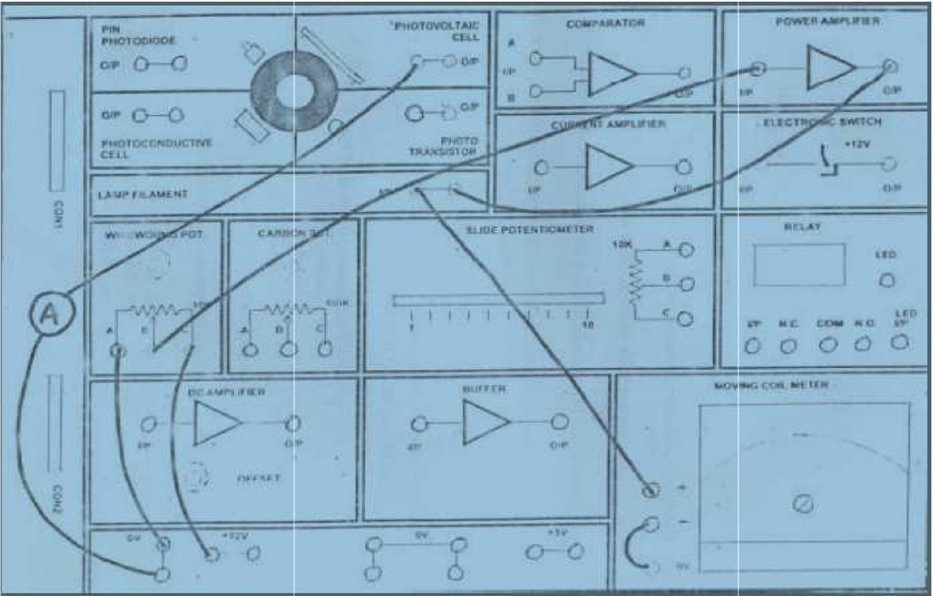

Procedure:

1. The circuit is completed as shown in the figure

2. All components are checked for working condition

3. Power supply is switched on

4. By rotating the knob of wire wound pot voltage can be varied, this illuminates the filament bulb and intensity is varied.

5. Note down the reading at 0V from voltmeter and current reading from Voltmeter.

6. Increase the voltage by the steps of 1V and note down the reading

Observation Table:

|  |  |  |  |  |  |  |  |  |  |  |  |
| --- | --- | --- | --- | --- | --- | --- | --- | --- | --- | --- | --- |
| **Lamp**  **Filament**  **Voltage**  **(volts)** | 0 | 1 | 2 | 3 | 4 | 5 | 6 | 7 | 8 | 9 | 10 |
| **Lamp Filament current**  (mA) | 0.13 | 21.44 | 32.69 | 42.05 | 49.89 | 57.12 | 63.80 | 69.94 | 75.62 | 81.42 | 86.33 |
| **lamp**  **Filament**  **Power**  (V x I)  (mW) | 0 | 21.44 | 65.38 | 126.15 | 199.56 | 285.6 | 382.8 | 489.58 | 604.96 | 732.78 | 863.3 |
| **Lamp**  **Filament**  **Resistance**  (V /I)  (ohms) | 0 | 0.0466 | 0.0612 | 0.0713 | 0.0802 | 0.0875 | 0.0940 | 0.1000 | 0.1058 | 0.1105 | 0.1158 |

Result:

Experiment is conducted and verified.

**EXPERIMENT-2**

Aim**:** CHARACTERISTICS OF PIN PHOTODIODE.

Circuit Diagram:

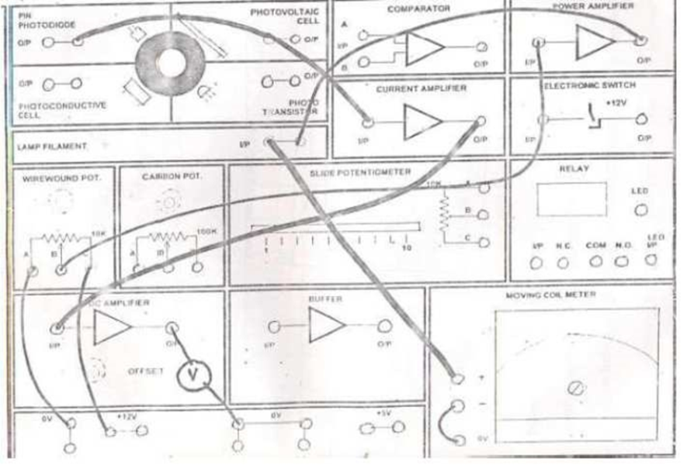

Procedure:

The circuit is completed as shown in the figure.

1. All the components are checked for working condition.
2. Power supply is switched on.
3. In the first case, keep the DC amplifier connected to the circuit.
4. By rotating the knob of wire wound pot. , the voltage can be varied. This illuminates the filament bulb and intensity is varied.
5. Note down the reading at 0V.
6. By increasing the voltage in steps of 1V, readings are noted.
7. Now disconnect the DC amp and connect to the BUFFER amp.
8. Note down the readings.

Observation table:

|  |  |  |  |  |  |  |  |  |  |  |  |
| --- | --- | --- | --- | --- | --- | --- | --- | --- | --- | --- | --- |
| Lamp Filament  Voltage  (Volts) | 0 | 1 | 2 | 3 | 4 | 5 | 6 | 7 | 8 | 9 | 10 |
| PIN Photodiode DC Amplifier output voltage  (Volts) | 0.06  7 | 0.093 | 0.114 | 0.168 | 0.289 | 0.509 | 0.813 | 1.265 | 1.853 | 2.510 | 3.456 |
| PIN Photodiode  Buffer output  (v) | 0.41 | 0.063 | 0.140 | 0.373 | 0.853 | 1.773 | 2.481 | 2.787 | 3.006 | 3.119 |  |

Result*:*

Respective experiment is conducted and verified.

**EXPERIMENT-3**

Aim: CHARACTERISTICS OF PHOTOCONDUCTIVE CELL

Circuit Diagram:

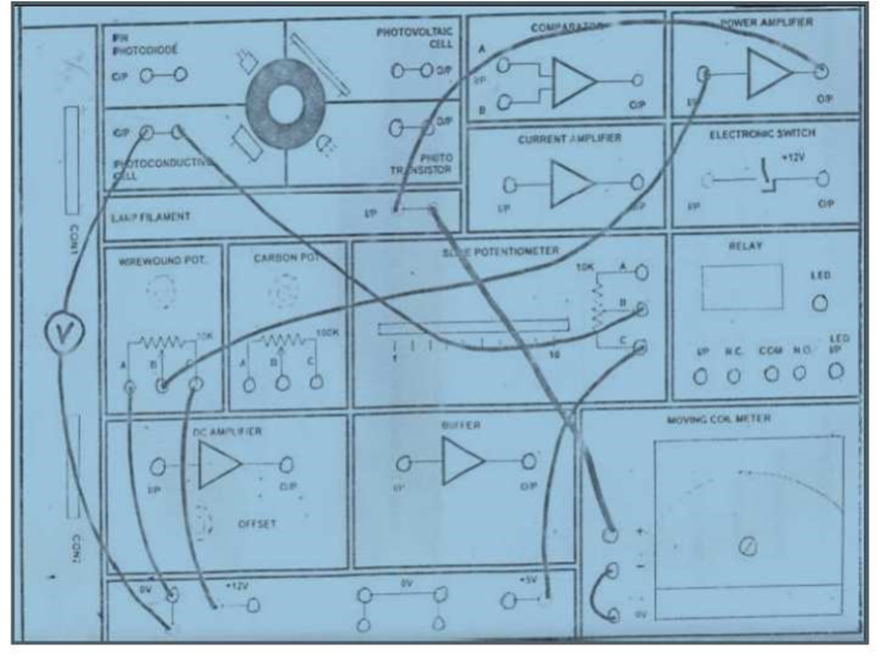

Procedure:

1. The circuit is completed as shown in the figure.
2. All the components are checked for working condition.
3. Power supply is switched on.
4. Keep the slide potentiometer in 3K position.
5. By rotating the knob of wire wound pot., voltage can be varied. This illuminates the filament bulb and intensity is varied.
6. Note down the reading at 0V from voltmeter and current reading from voltmeter.
7. Increase the voltage by the steps of 1V and note down the readings.

Observation Table:

|  |  |  |  |  |  |  |  |  |  |  |  |
| --- | --- | --- | --- | --- | --- | --- | --- | --- | --- | --- | --- |
| **Lamp**  **Filament**  **Voltage**  **(Volts)** | **0** | **1** | **2** | **3** | **4** | **5** | **6** | **7** | **8** | **9** | **10** |
| **Photo conductive cell adjust voltage**  **(Volts)** | **4.971** | **4.967** | **4.813** | **4.002** | **2.644** | **1.727** | **1.167** | **0.771** | **0.571** | **0.426** | **0.345** |

Result:

Respective experiment is conducted and verified.

**EXPERIMENT-4**

Aim: CHARACTERISTICS OF PHOTOTRANSISTOR CIRCUIT

Circuit Diagram:-

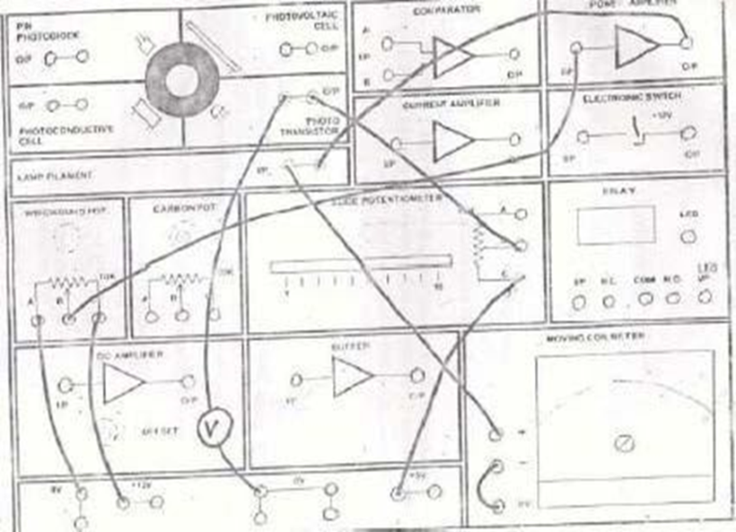

Procedure:

1. Circuit is connected is as shown in the figure.

2. Set the 10K ohm slide potentiometer control to min setting (1K ohm).

3. Switch on power supply and set the 10k ohm wire wound resistor to min for 0 output voltage from power amplifier.

4. Take readings of phototransistor output voltage as indicated on DMM as the lamp voltage is increased in 1 V step.

Observation Table:-

|  |  |
| --- | --- |
| **Lamp Filament**  **Voltage (V)** | **Photo Transistor o/p Voltage(V)** |
| 0 | 4.940 |
| 1 | 4.938 |
| 2 | 4.936 |
| 3 | 4.934 |
| 4 | 4.889 |
| 5 | 4.619 |
| 6 | 3.734 |
| 7 | 1.784 |
| 8 | 0.811 |
| 9 | 0.780 |
| 10 | 0.762 |

Result:

Experiment is conducted and verified.

**Experiment- 5**

Aim: CHARACTERISTIC OF FILAMENT LAMP

**Procedure:**

1. **Connect the circuit as required for the operation of filament lamp.**
2. **Switch on the supply.**
3. **Go on increasing the voltage scale by 1 step.**
4. **And take the corresponding readings of current.**
5. **Find the power.**

Observation Table:-

|  |  |  |  |  |  |  |  |  |  |  |  |
| --- | --- | --- | --- | --- | --- | --- | --- | --- | --- | --- | --- |
| **Lamp filament voltage (V)** | **0** | **1** | **2** | **3** | **4** | **5** | **6** | **7** | **8** | **9** | **10** |
| **Lamp filament current(mA)** | 0.14 | 20.73 | 31.93 | 41.09 | 49.94 | 56.74 | 63.67 | 69.58 | 75.28 | 85.56 | 86.74 |
| **Lamp filament power (mW)** | 0 | 22.36 | 64.44 | 122.14 | 198.90 | 280.75 | 384.08 | 486.12 | 600.45 | 730.88 | 868.6 |
| **Lamp resistance (ohms)** | **0** | **0.045** | **0.058** | **0.069** | **0.080** | **.088** | **0.096** | **0.105** | **0.109** | **0.112** | **0.116** |

Result:-

Experiment is conducted and verified.

COIS (Computerised Operator Information System)

It is a data acquisition and Display system for providing the operator with

Process parameter values and status

* Alarm messages
* History
* Printouts
* ECCS Test
* DNM Test

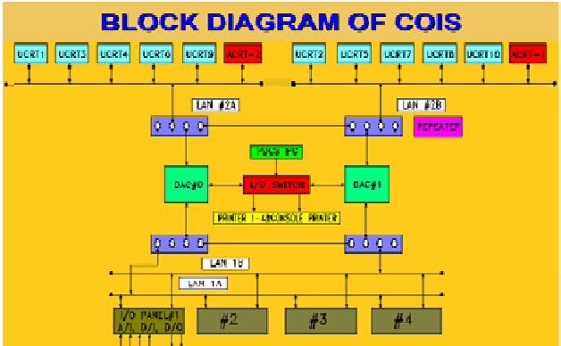

FUNCTIONS OF DATA AQUISITION SYSTEM:

Appl. Software – written in “c” functions:

– acquire data from i/o system

– pass the required data to

Display stations

– alarm task

– printer task

– storage of history

– data base management

– network management

– carryout dnm and eccs testing

– govern the field output Contacts

REPEATER

An active component which can be used to connect different cables of networks .It isolates the remaining

network from a fault in some other cable. For healthiness of repeaters check the flashing on all 4 repeaters every second.

COIS system overview:

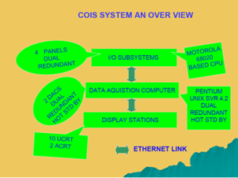

Function of display stations:

ALARM CRT (ACRT) - 2 NOS

– to alert the operator in case of alarm

UTILITY CRT(UCRT) - 10 NOS

– to display the various plant parameters in the desired formats as required by operator.

– to display the latest alarm/normal message at the bottom of all ucrts.

– to carry out the eccs and dnm testing.

– to get the desired printouts on any demand printer.

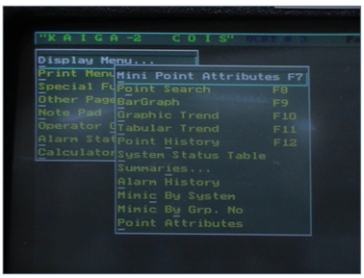

*Standard colour coding for analog and digital inputs:*

Green –normal

Red-Alarm

Blue-Bad signal

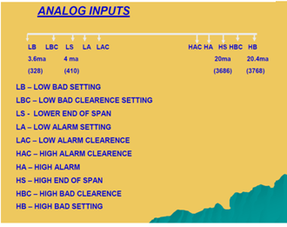

PRINTERS:

Alarm printer no. - 3

Demand printers no. – 1, 2

Supplementary c/r printer- 4

It accepts command from SCR UCRT only i.e. UCRT 10

PDCS (Programmable Digital Comparator System)

PDCS is a real time computer based system

• Which scans, conditions and digitalizes field signals.

• Generates alarm contacts when parameter crosses the set limits.

• Provides a centralised facility for monitoring the input signals...

• Provide the analog output for COIS/DRS/IM

Features:

Controlled access for the operator

• Online test facility

• self diagnostic features

• Incorporation of redundancy fault tolerance and fail safeness in the design Parameters monitored with an accuracy of±0.25%ffull scale..

• Inputs are scanned once in every 100msec.

• Generation of alarm contacts within200msec,

• Current inputs are connected via 10 ohm resistor.

• Analog buffered outputs are 1 to 5v

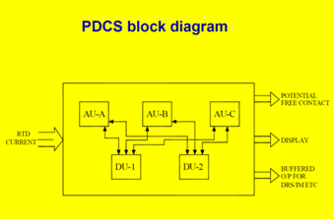

PDCS is functionally divided into an Alarm unit (AU) and Display unit (DU) with galvanic isolation.

Any problem in the DU side will not affect the functioning of AUs.

• AUs are triplicates (AU A,B,C )

•DUs are duplicated (DU 1,2 )

•With this type of design overall availability of the PDCS is 99.9 %

• AU, DU are based on 8687 CPU

Each AU receives 128 inputs.

A 1 to 255

B 1 to 255

C 1 to 255

Inputs are identified by odd numbers. It is possible to Disable/Enable/Set forced to alarm any NSR point..But for SR point sit is not possible

SR signals are routed through SR CDF located in channel rooms

NSR signals are routed through NSR CDF in Control room.

Valid Combinations:

SP1 should always be numerically lower than SP2 taking hysteresis into account.

|  |  |
| --- | --- |
| SP1 | SP2 |
| VL | L |
| L | VOID |
| VOID | L |
| HIGH | VOID |
| VOID | HIGH |
| HIGH | VERY HIGH |

ALARM RELAY ACTUATION

•When parameter moves over to alarm range. AU de energizes the alarm relay and contact will come open.

Alarm contact opens in case of power failure also.

• Both of the Alarm contact for particular PDCS point will open when signal goes to irrational low or irrational high condition.

CONCLUSION:

After completing industrial training, I come to know how the Theoretical concepts studied being implemented in practical concepts can help us correlate the two and as a consequence can bring about out of box innovations. Throughout the internship, I could understand how the power production done and prepare myself to become a responsible and innovative technician in future. Along my training period, I realize that observation is a main element to find out the root cause of a problem. Not only for my project but daily activities too. I cooperate with my colleagues and operators to determine the problems. Moreover, the project indirectly helps me to learn independently, discipline myself, be considerate/patient, self-trust, and take initiative and the ability to solve problems. Besides, my communication skills is strengthen as well when communicating with others. During my training period, I have received criticism and advice from engineers and technician when mistakes were made. However, those advices are useful guidance for me to change myself and avoid myself making the same mistakes again. In sum, the activities that I had learned during industrial training really are useful for me in future to face challenges in a working environment.

I was introduced to the various engineering aspects of a nuclear power plant. I was also shown Kaiga Simulator lab. I was also made to visit the Kaiga Power Plant Production unit. It was an overwhelming pleasure to see the theoretical concepts in real life.

Throughout the industrial training, I found that several things are important:

* **Critical and Analytical Thinking**

To organize our tasks and assignment, we need to analyse our problems and assignment, and to formulate a good solution to the problem. We would have to set contingency plan for the solution, so that we are well prepared for the unforeseeable situations.

* **Time Management**

As overall technician and programmer are always racing against tight timeline and packed schedule, a proper time management will minimize facing overdue deadlines. An effective time management allows us to do our assignment efficiently and meet our schedules. Scheduling avoids time wastage and allows us to plan and gaining more as a result.

* **Goal Management**

Opposing to a Herculean goal seemed to be reachable at first sight, it is better to sub-divide the goals to a few achievable tasks, so that we will be gaining more confidence by accomplishing those tasks.

* **Colleague Interactions**

In working environment, teamwork is vital in contributing to a strong organization. Teamwork is also essential in reaching the goals of the organization as an entity. Thus, communicating and sharing is much needed in the working environment. Therefore, we should be respecting each other in work, and working together as a team, instead of working alone. This is because working together as a team is easier in reaching our targets, rather than operating individually.

Hence, it was necessary to gain technical knowledge in all engineering disciplines. Overall, it was very fruitful.